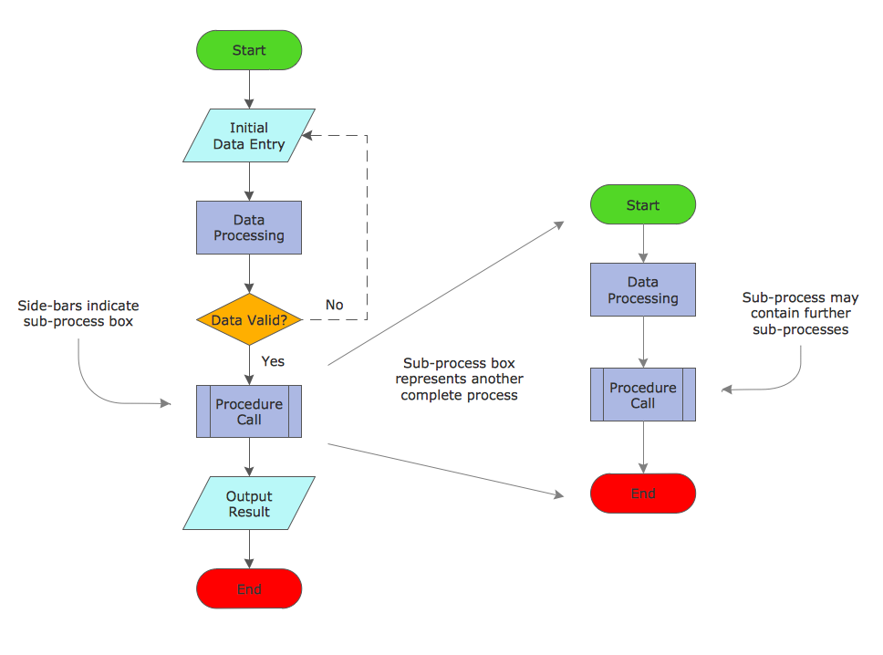

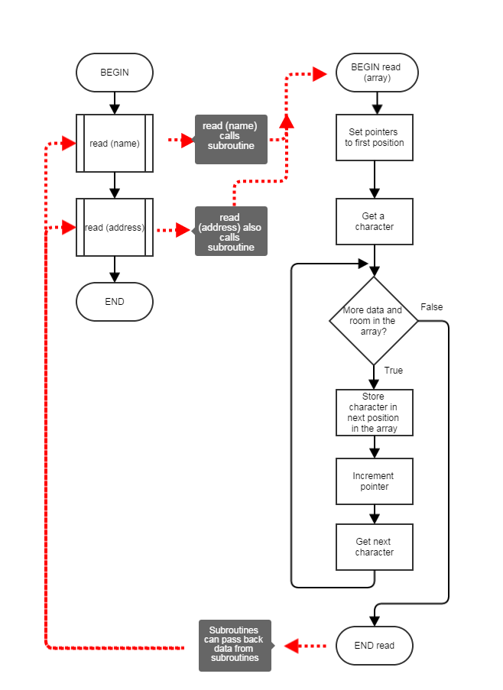

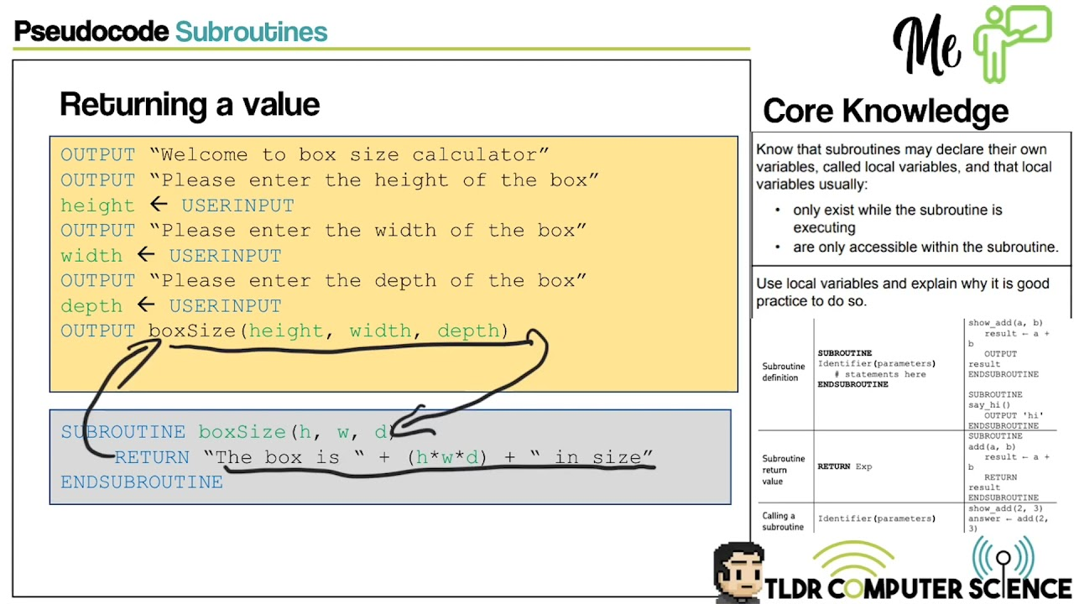

Pseudocode for Fibonacci Series up to n numbers:

Step 1: Start

Step 2: Declare variables a, b, c, n, i

Step 3: Initialize variables a=0, b=1, and i=2

Step 4: Read n from the user

Step 5: Print a and b

Step 6: Repeat until i = n:

Step 6.1: c = a + b

Step 6.2: Print c

Step 6.3: a = b

Step 6.4: b = c

Step 6.5: i = i + 1

Step 7: Stop

In this pseudocode:

* **a** and **b** represent the first two numbers of the Fibonacci series (0 and 1).
* **c** is the sum of the preceding two numbers.
* The loop continues until **i** reaches the user-defined value **n**.
* At each iteration, we print the value of **c**.

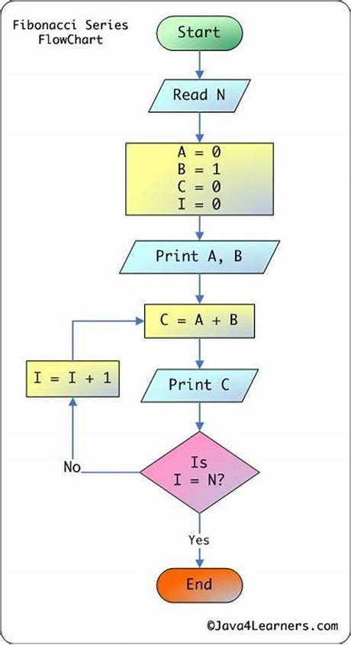

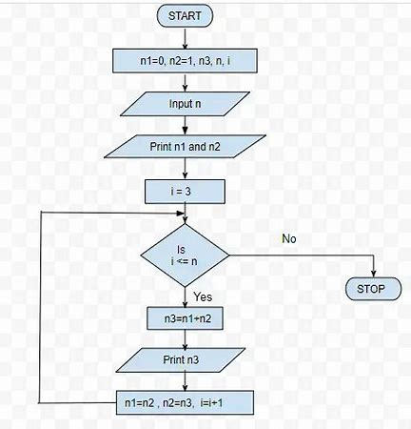

**Pseudocode for Factorial of a number :**

**Step 1:**Declare N and F as integer variable.

**Step 2:**Initialize F=1.

**Step 2:**Enter the value of N.

**Step 3:**Check whether N>0, if not then F=1.

**Step 4:**If yes then, F=F*N

**Step 5:** Decrease the value of N by 1 .

**Step 6:**Repeatstep 4and 5until N=0.

**Step 7:**Now print the value of F.

The value of F will be the factorial of N(number).